VISUALISING THE GLOBAL TEMPERATURE TREANDS

NAME- SUMANA JANA
COURSE- M.SC. IN STATISTICS
BATCH-2025-2027
INSTITUTE NAME-UNIVERSITY OF DELHI
Period of internship: 25th August 2025- 19th September 2025
Report submitted to: IDEAS-Institute of Data Engineering, Analytics and Science Foundation, ISI Kolkata.

CONTENTS:
- Abstract
- Introduction
- Project Objective
- Methodology
- Data Analysis and Results
- Conclusion
- Appendices
Abstract
The Earth's climate is undergoing significant changes, with global temperatures rising at an unprecedented rate due to human activities. This project aims to visualize long-term global temperature trends using historical climate data to better understand the extent and pattern of global warming. By employing data visualization techniques, including line graphs, heat maps, and anomaly plots, this study highlights temperature deviations from pre-industrial levels, identifies regional variations, and emphasizes the correlation between greenhouse gas emissions and rising temperatures. The visualizations provide an accessible and impactful representation of climate data, aiding in public awareness, scientific communication.
Introduction
Climate change has emerged as one of the most critical challenges facing humanity in the 21st century. A key indicator of climate change is the consistent rise in global temperatures, driven primarily by human-induced activities such as the burning of fossil fuels, deforestation, and industrialization. Understanding the trend of global temperature rise is essential not only for climate scientists but also for policymakers, educators, and the general public.
This project focuses on visualizing global temperature trends using historical climate data collected over the past century. By translating raw temperature records into meaningful visual formats—such as line charts, anomaly maps, and heatmaps—we aim to make complex climate data more accessible and comprehensible. These visualizations reveal patterns, anomalies, and the accelerating pace of warming across different regions and time periods.
Through this project, we seek to raise awareness about the severity of global warming and encourage data-driven discussions on sustainability and climate resilience. The visual approach helps in highlighting not just the global average rise in temperature, but also the regional disparities and seasonal fluctuations that characterize our warming planet. Python, Machine learning, Regression , LLM are also usedfull for statistical data analysis.

Project Objective
objectives for a project focused on visualizing global temperature trends:
- Understand Historical Temperature Changes
Visualize global temperature variations over time, helping to understand long-term climate change patterns.
- Compare Regional Climate Trends
Analyzed and compare how different regions of the world (e.g., polar, tropical, temperate zones) have experienced temperature changes.
- Identify Temperature Extremes
Highlight extreme temperature events, such as record highs or lows, and their frequency over time.
- Visualize Annual/Decadal Trends
Show trends in global temperatures on annual, decadal, or century scales to observe short- and long-term changes.
- Track Global Warming Effects
Visualize how the average global temperature has risen over recent decades, illustrating the phenomenon of global warming.
- Analyze Seasonal Variations
Examine seasonal temperature fluctuations and their contribution to overall climate trends (e.g., summer vs. winter changes).
- Investigate Impact of Human Activities
Correlate temperature trends with human activities like industrialization, deforestation, and emissions to better understand their impact.
Methodology
This project aims to visualize global temperature trends with a specific focus on India, using historical climate data. The methodology involves systematic steps including data acquisition, preprocessing, analysis, visualization, and interpretation to draw meaningful insights.

Data Preprocessing
Cleaning: Removed missing, inconsistent, or duplicate entries Formatting: Converted date formats, standardized temperature units (e.g., Celsius), and structured data for time-series analysis.
Filtering: Extracted India-specific data while retaining a subset of global data for comparison.
Data Analysis
Trend Analysis:
Calculated annual and monthly average temperatures for India.
Identified long-term trends using moving averages or regression models.
Comparison with Global Trends:
Compared India’s temperature trend with global averages.
Analyzed the rate of change and significant anomalies (e.g., heatwaves, cold years).
Statistical Tools Used:
Pandas, NumPy for data manipulation.
Matplotlib, Seaborn for basic plotting.
Plotly for interactive visualizations.
Visualization
Developed visualizations to illustrate key findings:
Line Graphs: Year-wise temperature trends.
Heatmaps: Seasonal and regional temperature variations across Indian states.
Bar Charts: Decade-wise average temperature changes.
Geospatial Maps: Used libraries like Folium or GeoPandas to visualize temperature variation across regions of India.
Added interactivity using tools like Plotly Dash, Tableau, or Power BI for dynamic exploration.
Tools and Technologies Used
Programming: Python (Jupyter Notebook)
Libraries: Pandas, NumPy, Matplotlib, Seaborn, Plotly, GeoPandas
Visualization Platforms: Tableau or Power BI (optional)
Data Analysis and Results:
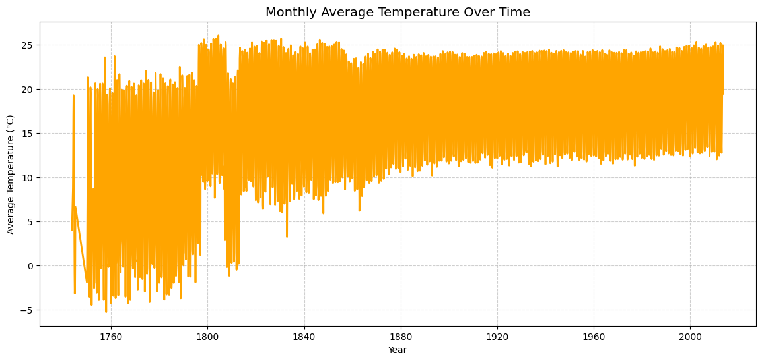

The plot likely represents a long-term climate dataset showing monthly average temperatures. The increasing lower bound of the temperature values over time suggests gradual global warming or urbanization effects influencing local climate. The dense orange region indicates seasonal cycles repeating each year — warmer months and cooler months — but overall temperatures trending higher in later years.
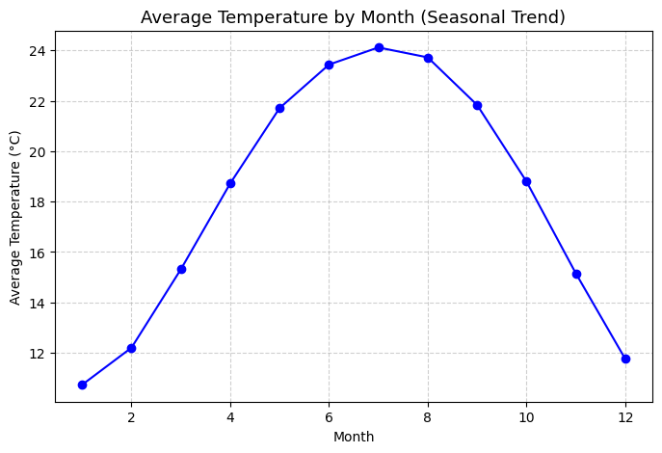

The graph reflects a clear and stable seasonal climate pattern.
The symmetry around mid-year suggests predictable temperature cycles likely driven by solar radiation and Earth’s tilt.
The temperature difference (about 13°C between peak and trough) indicates moderate seasonal variation, typical of regions with mild winters and warm summers.

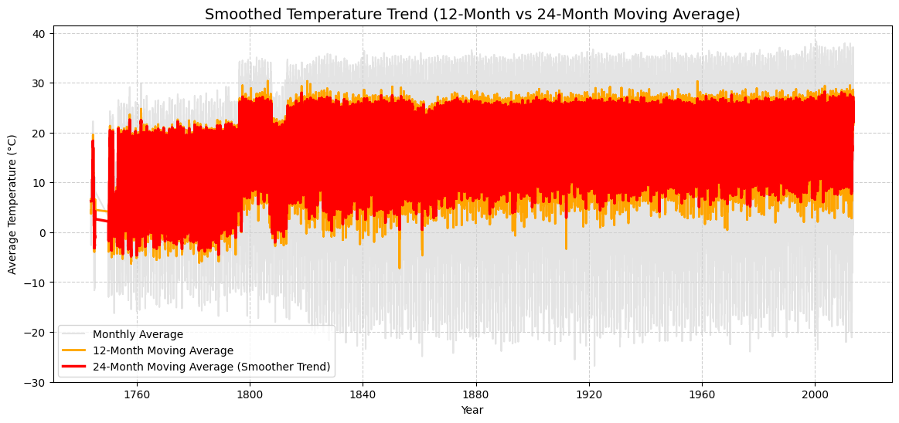

This graph effectively demonstrates how smoothing (using moving averages) helps in revealing underlying temperature trends hidden by short-term fluctuations.
While raw data (grey) shows high variability, the smoothed lines (orange and red) clearly illustrate a progressive warming pattern, especially in recent centuries — consistent with global climate change trends.

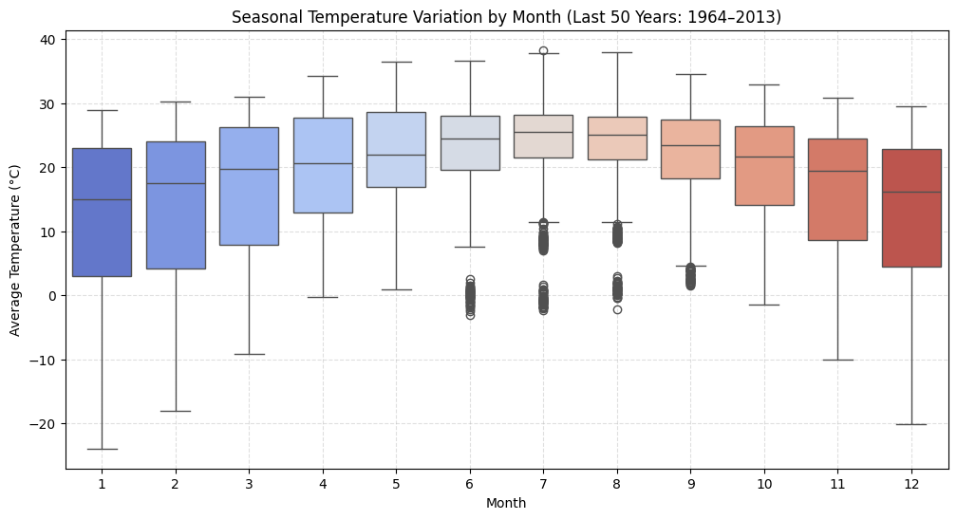

The graph effectively shows clear seasonal temperature cycles over 50 years.
Temperatures rise steadily from winter to summer and decline afterward.
The consistent warm peak around June–July and colder troughs around January–February confirm typical seasonal climate behavior.
The presence of outliers highlights occasional extreme weather events.
Overall, this visualization captures both regular seasonal trends and temperature variability across decades.

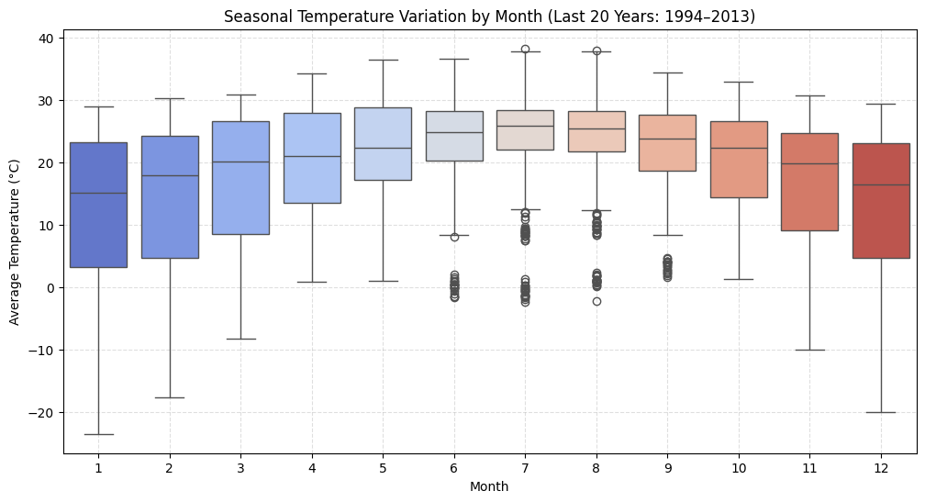
This graph effectively displays the seasonal temperature variation over the last two decades.
The pattern confirms distinct seasonal cycles, with peak temperatures in mid-year (June–July) and the lowest in early months (January–February).
Compared to longer-term data, the range appears slightly narrower, suggesting more stable temperature patterns in recent years.
However, the presence of outliers highlights occasional extreme weather events, which could be linked to short-term climatic fluctuations.

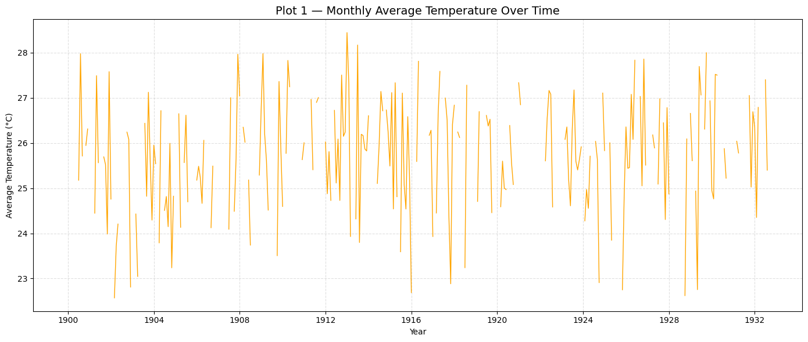
This graph illustrates the monthly temperature variability over the early 20th century (1900–1933).
Although short-term fluctuations are frequent and sometimes sharp, the overall average temperature remains relatively stable throughout the period.
No significant warming or cooling trend is evident, suggesting that during these years, climate conditions remained consistent, with changes primarily reflecting seasonal and short-term variations rather than long-term climatic shifts.

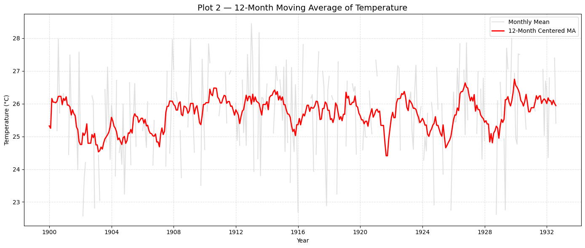

The graph illustrates that from 1900 to 1933, temperatures experienced short-term variations but no clear long-term warming or cooling trend.
The 12-month moving average effectively smooths the noise of monthly fluctuations, showing that the early 20th century was a period of climatic stability, with temperatures oscillating mildly around a steady mean of about 25°C.
This suggests that during this time, natural variability dominated, and significant climate change patterns were not yet apparent.

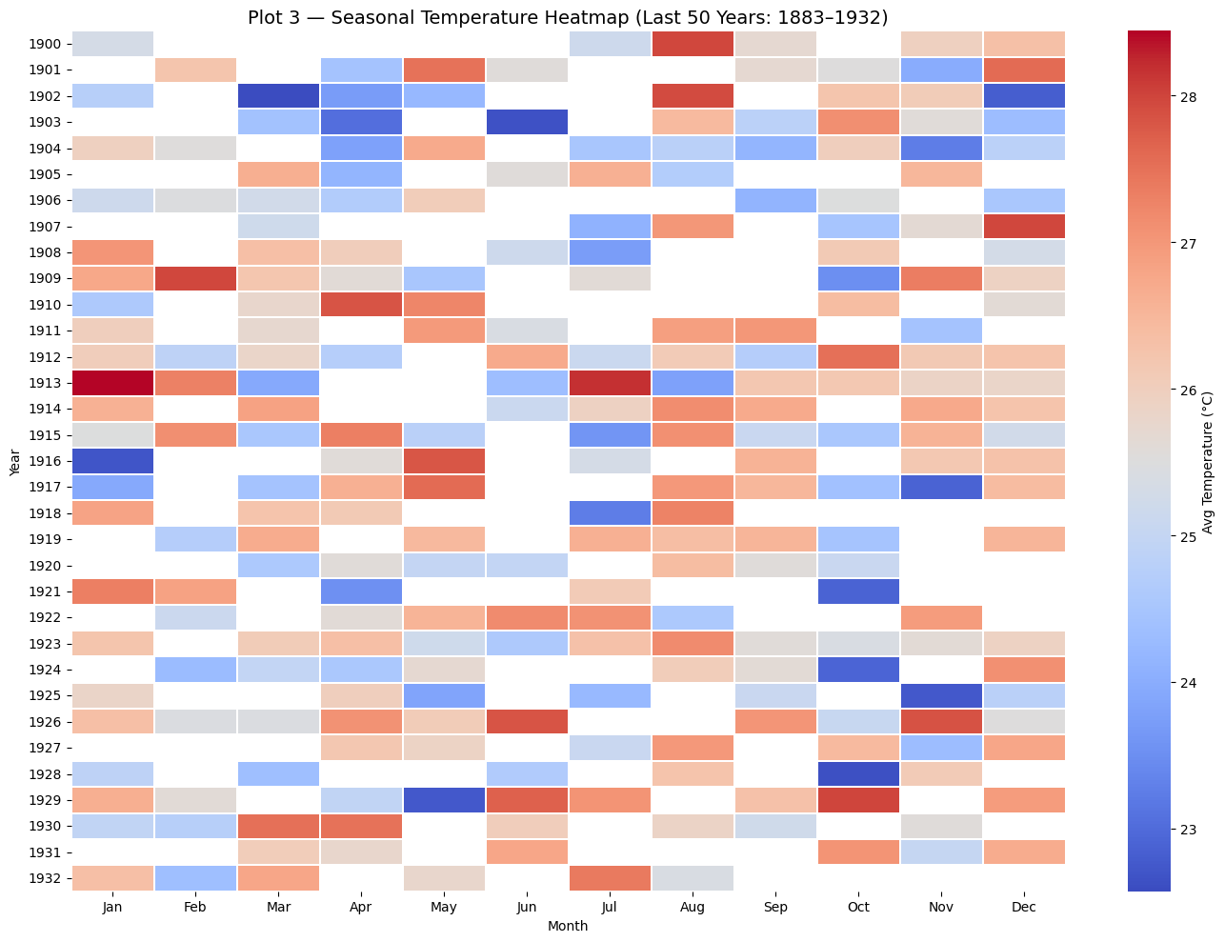

This heatmap effectively highlights seasonal and interannual temperature variations over a 50-year span (1883–1932).
It demonstrates a stable climate pattern, with predictable warm and cool periods repeating annually.
Although some years exhibit brief warm or cool anomalies, there is no evident long-term increase in average temperature, indicating that during this historical period, natural temperature variability dominated rather than progressive climate change.
Overall, the graph visually reinforces the regularity of seasonal cycles and the consistency of early 20th-century temperature trends.

Appendices
1.https://www.climate.gov/news-features/understanding-climate/climate-change global-temperature
2.https://climate.copernicus.eu/global-climate-highlights-2024
Global Temperature Report for 2023 - Berkeley Earth 3. 3.https://berkeleyearth.org/global-temperature-report-for-2023/
4.essd-16-2625-2024.pdf https://share.google/fIuMVXOHedKxAkLxA

